**EXCELL ASSIGNMENT -8**

**QUESTION 1.** **What do you mean by AutoComplete feature in Excel and what are the benefits of using this feature?**

**ANSWER=** In Microsoft Excel, the AutoComplete feature is a tool that helps users save time and reduce errors by automatically filling in data based on patterns or entries already present in the spreadsheet. When you start typing a value in a cell, Excel predicts and suggests possible completions based on existing entries in the same column

**Benefits of AutoComplete in Excel:**

1. **Efficiency:** AutoComplete helps users work more efficiently by reducing the need to manually type repetitive or similar data. It speeds up data entry processes.
2. **Consistency:** It promotes data consistency by suggesting values already present in the column. This helps avoid typos and ensures that data is entered in a standardized manner.
3. **Accuracy:** Since AutoComplete suggests entries based on existing data, it helps minimize errors in data entry. This is particularly useful when dealing with long lists or datasets.
4. **Time-Saving:** By automatically suggesting and completing entries, AutoComplete saves time that would otherwise be spent on typing repetitive information.
5. **Ease of Use:** The feature is easy to use and requires minimal effort. Users can take advantage of it without having to learn complex procedures.
6. **Reduced Workload:** For large datasets, AutoComplete can significantly reduce the workload on users by simplifying the process of entering similar or related information.

**QUESTION 2 . Explain working with workbooks and working with cells.**

**ANSWER =**

**Working with Workbooks:**

1. **What is a Workbook?**
   * A workbook in Excel is a file that can contain one or more worksheets.
   * It is the top-level container for all the data and sheets in Excel.
2. **Creating a Workbook:**
   * Open Excel and go to "File" > "New" to create a new workbook.
3. **Managing Worksheets:**
   * By default, a new workbook starts with one worksheet. You can add more sheets by clicking the "+" button near the sheet tabs at the bottom or by right-clicking on a sheet tab and selecting "Insert."
4. **Renaming Worksheets:**
   * Double-click on the sheet tab to rename it according to your preference.
5. **Saving a Workbook:**
   * Save your workbook using "File" > "Save" or Ctrl + S (Windows)
   * Choose a location and provide a name for your workbook.
6. **Closing a Workbook:**
   * Close a workbook using "File" > "Close" or the keyboard shortcut Ctrl + W (Windows) Working with Cells:
7. **Navigating Cells:**
   * Click on a cell to select it. You can also use arrow keys to move around cells.
   * The selected cell is highlighted, and its address is shown in the Name Box.
8. **Entering Data:**
   * Click on a cell and start typing to enter data.
   * You can enter numbers, text, dates, or formulas into cells.
9. **Cell References:**
   * Cells are identified by their column and row labels (e.g., A1, B2).
   * Formulas often use cell references to perform calculations based on the data in specific cells.
10. **Formatting Cells:**
    * Change the appearance of cells using the "Home" tab. You can format font, alignment, borders, and more.
11. **Copying and Pasting:**
    * Copy data from one cell and paste it to another using the "Copy" (Ctrl + C) and "Paste" (Ctrl + V) commands.
12. **Formulas and Functions:**
    * Use formulas to perform calculations based on cell values.
    * Excel provides a wide range of functions (e.g., SUM, AVERAGE) for various calculations.
13. **AutoFill:**
    * Drag the fill handle (a small square at the bottom-right corner of a selected cell) to fill adjacent cells with a series, data, or formulas.
14. **Merging and Splitting Cells:**
    * Merge cells to combine them into a single cell. Use the "Merge & Center" button on the ribbon.
    * Split cells that were previously merged by selecting them and choosing "Unmerge Cells."

**Question 3 . What is fill handle in Excel and why do we use it?**

**ANSWER=**

The fill handle in Excel is a small square at the bottom-right corner of a selected cell or range of cells. It is a powerful and convenient tool that allows you to quickly fill data, create series, copy formulas, and perform other repetitive tasks. The fill handle is represented by a small square dot, and it is located in the lower-right corner of the border surrounding the selected cell or range.

**QUESTION 4. Give some examples of using the fill handle.**

**ANSWER=**

**1. AutoFill Series:**

* Example: Enter "1" in cell A1, then drag the fill handle down to fill cells A2, A3, and so on. Excel will automatically fill the series with consecutive numbers.

**2. Copy and Paste Formulas:**

* Example: Enter a formula in cell B1, such as "=A1*2". Drag the fill handle from the bottom-right corner of B1 to fill cells B2, B3, and so on. Excel will copy the formula and adjust cell references accordingly**.**

**3. Fill Weekdays:**

* Example: Enter "Monday" in cell C1, then drag the fill handle to fill cells C2, C3, and so on. Excel will automatically fill the sequence with the following weekdays.

**4. Custom Series:**

* Example: Enter "Jan" in cell D1 and "Feb" in cell D2. Select both cells and drag the fill handle down to fill cells D3, D4, and so on. Excel will extend the series with the subsequent months.

**5. Fill Formatting Only:**

* Example: Format cell E1 with a specific font color. Enter a value in cell E2, and then use the fill handle with the right-click option to "Fill Formatting Only" to copy the formatting to other cells**.**

**QUESTION**  **5. Describe flash fill and what the different ways to access the flash fill are.**

**ANSWER=**

Flash Fill is a feature in Microsoft Excel that automatically recognizes patterns in your data and fills adjacent cells accordingly. It is particularly useful when you need to extract, combine, or format data based on a specific pattern. Flash Fill is designed to save time and reduce the need for manual data manipulation.

**Different Ways to access the flash fill**

1. **Keyboard Shortcut:**
   * After entering the desired pattern in a cell, press Ctrl + E (Windows)
2. **Ribbon Option:**
   * Go to the "Data" tab on the ribbon.
   * Click on the "Flash Fill" button in the "Data Tools" group.
3. **Right-Click Context Menu:**
   * After entering the desired pattern, right-click on the cell.
   * From the context menu, choose "Flash Fill."
4. **Automatic Activation:**
   * In some cases, Excel may automatically detect patterns and suggest Flash Fill options when you start typing data in adjacent columns**.**

**QUESTION 6.** **Extract first name and last name from the mail id and then from the**

**address column, extract the city, state, and pin code using the flash fill.**

**Given below is an example of the columns you have to create. Paste the**

**screenshot of what you have created using the flash fill command.**

**Example: Mail Id, Address, First name, Last name, State, City, Pincode**

**Answer= *Extract first name and last name from mail id***

**For first name** , select B2 and write name as rishabh the select B3 and press CTRL+E

**For last name ,** select C2 and write last name as singh then select C3 and press CTRL+E

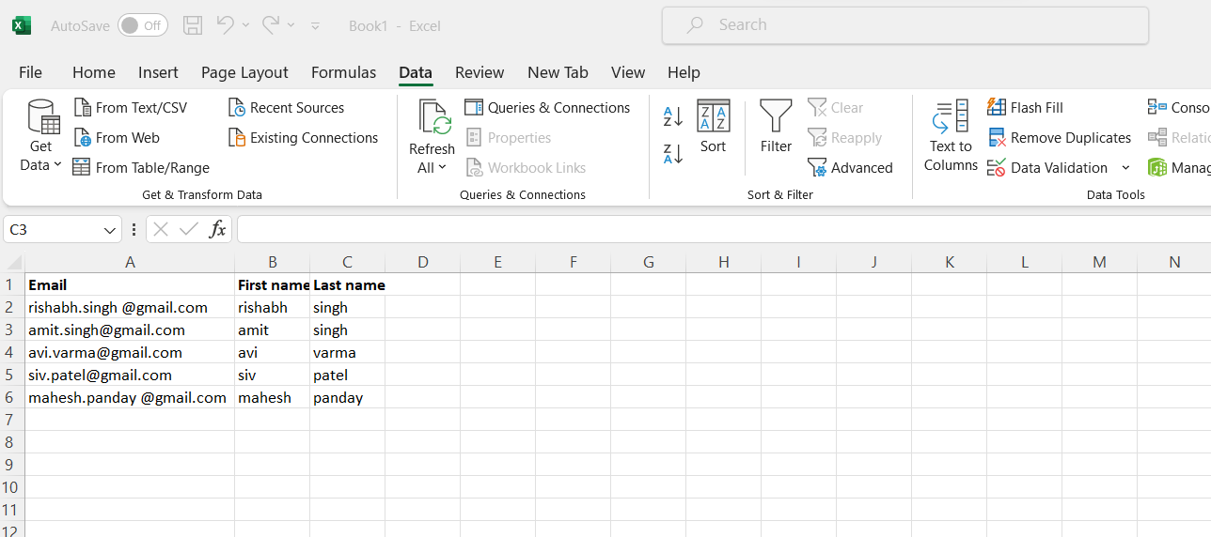

***Now, Extract city name , state, pin from Address***

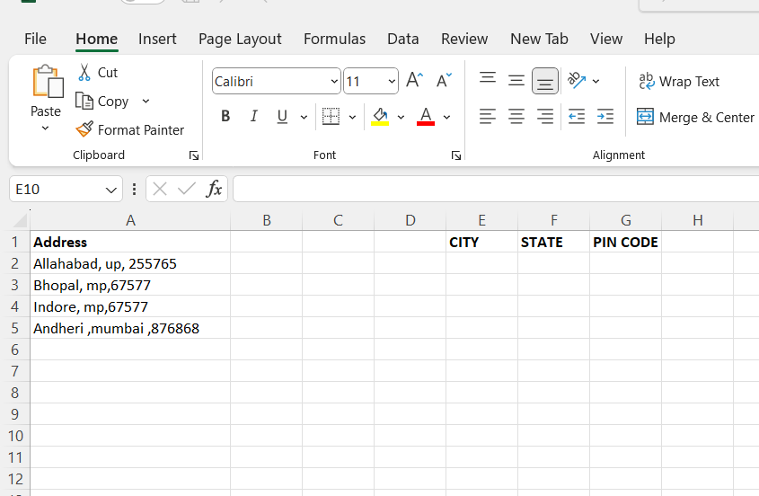

**For city name , state, pin code first we select column A then go to DATA tabe click on text to column under Data Tool**

